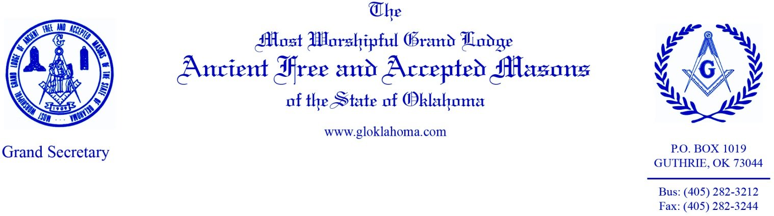
January 10, 2017
Dear Brethren,
The Grand Secretary and Executive Director of the Masonic Charity Foundation will be conducting six (6) Secretary/ Charity Foundation Workshops for 2017. Each lodge is encouraged to return the registration forms as soon as possible with the date/location you plan to attend, so that appropriate amount of materials are prepared. The cost for registration is $20.00 to cover the cost of the materials. Attendance by any lodge officer, not just secretaries is highly encouraged.
Topics will include forms and materials of the Grand Lodge, reports, and other issues pertinent to daily operation of your lodge. W∴ John Logan, Executive Director of the Masonic Charity Foundation, will also be there to answer questions and explain Matching Funds, Promises Matter, and other Foundation-related issues that affect your lodge.
- Saturday, February 25, 2017 @ 9:00 AM – Delta Lodge 425
- Saturday, March 18, 2017 @ 9:00 AM – Grand Lodge
- Wednesday, March 29, 2017 @ 5:00 PM – Lawton Lodge 183
- Wednesday, April 26, 2017 @ 5:00 PM – McAlester Lodge 9
- Tuesday, May 30, 2017 @ 5:00 PM - Garfield Lodge 501
- Wednesday, May 31, 2017 @ 5:00 PM – Woodward Lodge 189

Please register using the included form and return to the Grand Lodge as soon as possible. These dates and locations are subject to change based on weather and event conflicts. Each lodge and participant will be notified of any changes.

Fraternally,
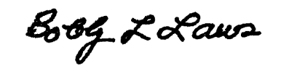
Bobby L. Laws
Grand Secretary

2017 SECRETARY’S & CHARITY FOUNDATION WORKSHOP
REGISTRATION FORM

________________________ Lodge No. ____________

Secretary/ Charity Foundation Workshops listed below are scheduled for this year. There are no restrictions on who or how many from your Lodge may participate. Please indicate which workshop you will attend by marking the corresponding box, complete the attendee information below. Please return your registration soon as possible to assist us with seating space and course preparations.

Workshops Available:
February 25, 2017 @ 9:00 AM – Delta Lodge 425

March 18, 2017 @ 9:00 AM – Grand Lodge

March 29, 2017 @ 5:00 PM – Lawton Lodge 183

April 26, 2017 @ 5:00 PM – McAlester Lodge 9

May 30, 2017 @ 5:00 PM - Garfield Lodge 501

May 31, 2017 @ 5:00 PM – Woodward Lodge 189
Name (print) | Title | Email | Cell | $20.00
 |  |  |  | $
 |  |  |  | $
 |  |  |  | $
 |  |  |  | $
 |  |  |  | $
 |  |  | Total Due | $

Please return this form along with a check payable to the Grand Lodge of Oklahoma for the total amount due.

Grand Lodge of Oklahoma
P.O. Box 1019
Guthrie, OK 73044-1019

